***Supplementary Figures***



Supplementary Figure 1. A) Biogas production following treatment of slurry with the full additive (UHP+KI variant) or individual components of the additive, over two treatment phases where treatments were applied on day 0 of each. B) Ammonium content of cattle slurry following treatment with either the full additive (UHP +KI variant) or individual components of the additive, where samples were taken 13 days after the first treatment, and 17 days after the second treatment.



Supplementary Figure 2. Change in slurry pH in untreated (green), UHP+KI treated (red) and SPC+KI treated (blue) slurry samples.



Supplementary Figure 3. Total and volatile solids content of feedstock used during the 150 day trial, which comprised FOG and cattle slurry (1:2). Days where untreated cattle slurry was used are denoted by green, while those where slurry treated with the additive are in red.



Supplementary Figure 4. A) pH in the feedstock (square symbol) and within triplicate reactors over during the 150 day trial, B) Median and interquartile ranges of pH in FS and reactors summarised over the whole trial where statistically significant differences in mean are denoted by asterisks (** symbolises p < 0.01). Colour denotes the slurry used within the feedstock (untreated = green; treated with UHP+KI additive = red) along with FOG (1:2).



Supplementary Figure 5. Ammonia content of the feedstock and the reactors, where feedstock was comprised of 1:2 ratio of FOG and either untreated (green) or UHP+KI additive treated (red) cattle slurry.

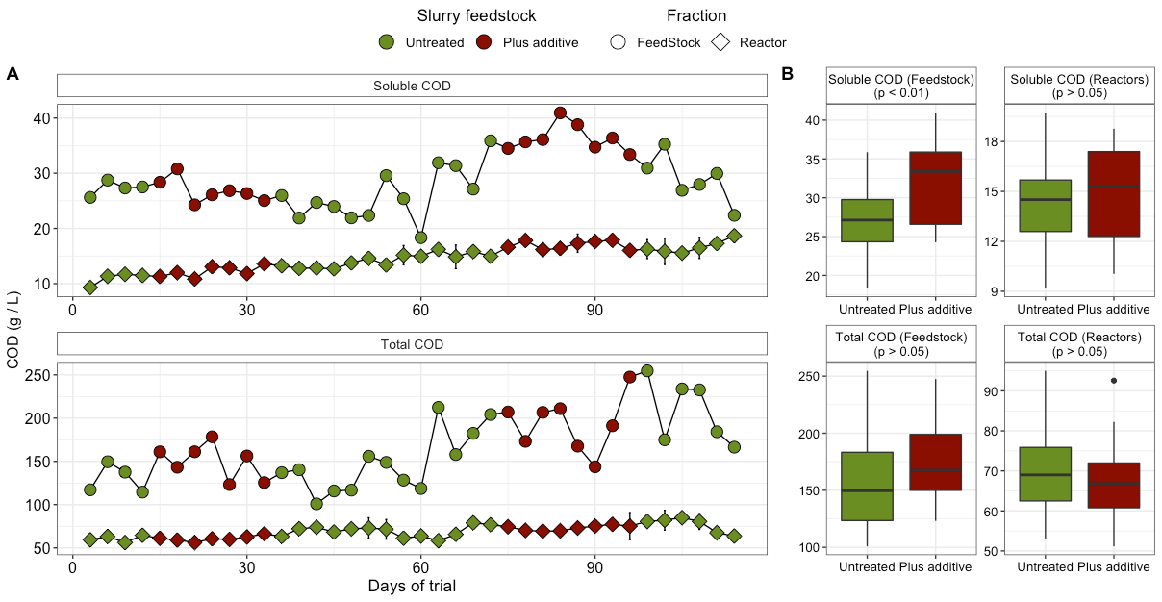

Supplementary Figure 6. A) Soluble and total COD in the feedstock (circle symbol) and within triplicate reactors (diamond) over during the 150 day trial, B) Median and interquartile ranges of CODs in FS and reactors summarised over the whole trial where statistically significant differences in mean are denoted by relevant p value.



Supplementary Figure 7. Methane production per gram of soluble COD fed, from replicated lab scale anaerobic digesters co-fed with untreated (green) or UHP+KI treated (red) slurry and food production waste, where slurry samples were taken from the end of the trial in Figure 7. Mean of triplicate reactors is plotted, with error bars denoting standard deviation.